Domain Group: Child
Expert Guest(s): Warren Hays, KDHE; Cheryl Johnson, KSDE; Christi Smith, CCA-KS (tentative, phone); Shelly Summar, Children’s Mercy
Lead Staff: Elisa Nehrbass Recorder: Brooke Sisson

Instructions: Provide brief responses to the following questions related to the focus area/issue.
Discussion Questions | Comments
- What is the problem/focus issue? | The 2018 Physical Activity Guidelines (https://health.gov/paguidelines/second-edition/ (for Americans recommend that children and adolescents ages 6-17 get at least 60 minutes of physical activity daily with most of the 60 minutes being either moderate- or vigorous-intensity aerobic physical activity. The data reveals we have less than 27% of children reaching this goal. The newest 2018 guidelines (previous were 2008) include key recommendations for preschool-aged children ages 3-5 years as well as updated recommendations for adults, pregnant and postpartum women, and adults with disabilities and chronic conditions. Another unmet target related to physical activity in children is the Healthy Kansans 2020 target of “modeling level” for a minimum of at least 1 of each of the 5 physical activity wellness guideline categories (see school wellness guidelines link below).  How can we promote incorporating physical activity into the daily routine for children at home, child care, school, and the community?  Consider: What is already happening in this area—is there anything MCH can further support that’s already happening at the state or local levels? (e.g., partner with BHP, Governor’s Council on Fitness, CDRR grantees, KSDE, Kansas schools, child care providers)  What information or resources can we leverage to utilize for MCH populations and partnerships?
- Who is the target audience for the message(s)? | Audiences could be the home/family, school, child care, and/or community. Consider community supports to promote activity at/across all settings including indoor and outdoor (park, playgrounds, etc.). Consider CYSHCN: Are playgrounds accessible with options?
- What type of document/product related to outreach/messaging are you preparing (what is the purpose) and why? (action alert, infographic, bulletin, etc.) | Action Alert/Call to Action  (Use data, strategies, tips, and reminders to send the messages to impact behavior; intent is to mobilize and activate/create and drive action across sectors – we are all a part of the solution and can do something now.)
- What MCH performance measure does this aim to address/support? | SPM 3: Child Physical Activity (% of children 6-11 years who are physically active at least 60 minutes per day)
- Outline the case for need:  - Data/negative trends  - Behaviors to target for change that are contributing to the issue  - System and/or policy issues and barriers contributing to the problem  - Other contributing factors | Data: The most current data indicates only 26.7% of Kansas children ages 6-11 were physically active for at least 60 minutes, seven days a week. There were no significant disparities by gender, race/ethnicity, special health care needs, parental educational attainment, health insurance, household income-poverty ratio, household structure, or nativity. (Source: 2016*-2017 combined National Survey of Children’s Health, based on parent-reported data) SEE ATTACHED  Behaviors to Target:  System and/or Policy Issues:  Barriers to Address:  Other Factors to Consider:
- What are the “asks” from the audience? What changes/actions can make a difference? Specifically, how should we move forward with this “issue” area that needs to be advanced?
(Carry to action alert worksheet.)
NOTE: Break strategies/actions for change down by target population and provider or setting type
- What key message(s) or resources (phone numbers, websites, etc.) need to be communicated or promoted?
(Carry to action alert worksheet.)
NOTE: Break message down by target population and provider or setting type, if appropriate.

- Sources/References

MCH State Action Plan Objectives & Strategies:
- Increase the percent of children participating in at least 60 minutes of daily physical activity per CDC recommendations to decrease risk of obesity by 2020.
  - Provide training and resources to child care providers related to healthy practices and regulatory requirements to encourage and support implementation of daily routines involving physical activity.
  - Increase the number of community programs, including early care settings, collaborating with MCH programs to promote participation in regular physical activity including engaging and educating families.
  - Support local health departments, early care settings, schools, and community centers in local initiatives to promote physical activity and utilization of safe walking and biking trails (Ex. Walking School Bus).

What, if any recommendations, does the group have for the MCH State Action Plan related to this issue? Consider and discuss the following:
Is the issue/need adequately addressed in the plan?  Circle one (yes or no) and explain. | Yes | No
Does the group recommend any strategies to advance the work or improve the outcomes/measures?  Circle one (yes or no) and explain. | Yes | No

Significance & Data:
- Regular physical activity can improve the health and quality of life of Americans of all ages, regardless of the presence of a chronic disease or disability. Physical activity in children and adolescents reduces the risk of early life risk factors for cardiovascular disease, hypertension, Type II diabetes, and osteoporosis. In addition to aerobic and muscle-strengthening activities, bone-strengthening activities are especially 74 important for children and young adolescents because the majority of peak bone mass is obtained by the end of adolescence. U.S. Department of Health and Human Services. Original 2008 Physical Activity Guidelines for Americans https://health.gov/paguidelines/guidelines/ 2018 2nd Ed. Physical Activity Guidelines: https://health.gov/paguidelines/second-edition/

HEALTHY PEOPLE 2020 OBJECTIVE Related to Physical Activity: Increase the proportion of the Nation’s public and private elementary schools that require daily physical education for all students. (Baseline: 3.8%, Target: 4.2%)

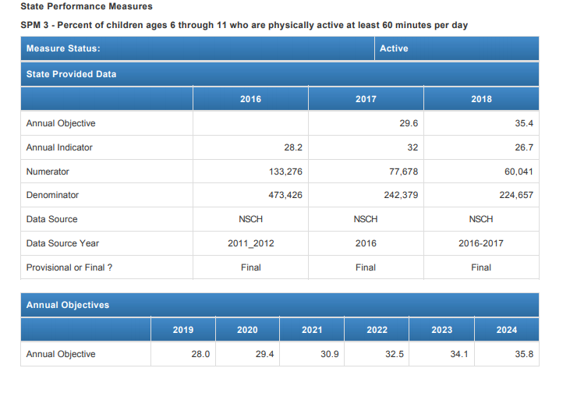

Resources:
- 2018 Physical Activity Guidelines, 2nd Ed. https://health.gov/paguidelines/second-edition/
  - Move Your Way Campaign: Resources to help promote the new physical activity guidelines.
    - Move Your Way Campaign materials
    - Move Your Way Partner Promotion Toolkit
    - Move Your Way website for consumers
    - Presentation for professionals to use to explain and promote the Guidelines (PDF): https://health.gov/paguidelines/second-edition/pdf/Physical_Activity_Guidelines_2nd_edition_Presentation.pdf (PPT version also available online.)
- Children and Adolescents with Disabilities: There is an increased focus on children, youth, and adults with disabilities and chronic conditions. While adults with disabilities and chronic conditions have their own chapter, children and adolescents with disabilities should use the same guidelines as all children and adolescents. Page 53 of the guidelines addresses special considerations for children/youth with adolescents.
- School Wellness Guidelines https://www.kn-eat.org/SNP/SNP_Docs/SNP_Guidance/Wellness_Policies/Wellness_Policy_Guidelines_Booklet_Final_2017.pdf
- Multiple reference resources from Warren Hays, Physical & Activity Director, Bureau of Health Promotion, KDHE and Cheryl Johnson, Director, Child Nutrition & Wellness, KSDE

